**Java Quality Estimator Manual**

Gustavo Henrique Paetzold

**1. Introduction**

In this document, we introduce the Java Quality Estimation tool developed for Iconic Translation Machines Ltda. The tool is capable of not only training models over annotated data, but also to use such models to predict the quality of unseen translations.

**2. Installation**

Since the tool is composed of a compiled JAR file, there is no need for installation. To use it, one needs only to place the IconicQualityEstimator.jar file in a certain folder, and use a terminal or command prompt to explore the tool’s functionalities.

**3. Source Code**

The tool’s code is distributed as a NetBeans project, and can be found in the “IconicQualityEstimator” folder. It is compiled over Java’s JDK 1.8, and uses two libraries: libsvm and quest-vanilla. To re-compile the project, the user can open the project in NetBeans and use the “Clean and Build” option. A more practical alternative, however, is to compile the project as a “packed” (or “fat”) JAR, which means that, when compiled, the JAR file will not require for the libsvm and quest-vanilla libraries to be distributed along with it, since they will be “packed” inside the main JAR itself. To re-compile the project as a packed JAR, the user must follow the steps below:

1. Open the projects in NetBeans.
2. Use the “Clean and Build” function (Shift+F11).
3. Change from the “Projects” to “Files” view.
4. Right-click the “build.xml” file and select the “Run Target -> Other Targets -> package for store” option. Figure 1 illustrates this process.

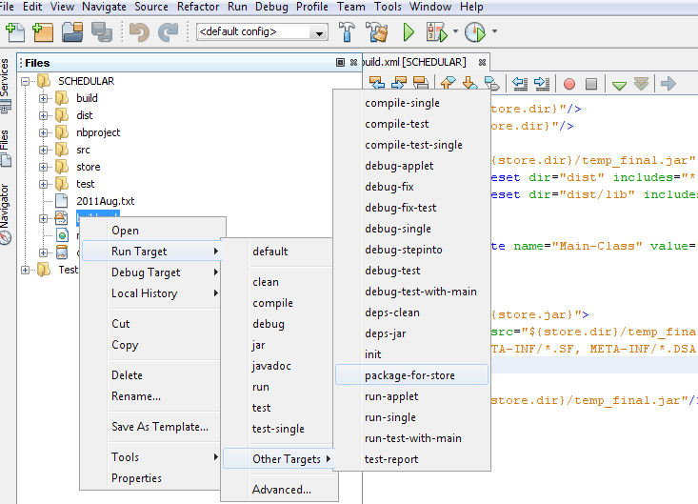

**Figure 1** – Packed JAR compilation process

If the steps are performed correctly, the user will find the packed IconicQualityEstimator.jar file in the “store” folder, inside the NetBeans project’s root folder. The libsvm and quest-vanilla libraries can also be modified and recompiled if necessary.

**3.1. libsvm**

The libsvm library allows for one to train Support Vector Machine (SVM) models easily. The version used by the Iconic Quality Estimator is personalized, and contains classes and functions modified specifically to fit the requirements of this project. The modified source code of libsvm is also distributed as a NetBeans project, and can be found in the “libsvm-modified” folder.

**3.2. quest-vanilla**

Like the libsvm library, quest-vanilla is a personalized version of QuEst++ (<https://github.com/ghpaetzold/questplusplus>), created specifically for this project. It is much lighter than the original version of QuEst++, and supports only sentence-level quality estimation. The source code of quest-vanilla is also distributed as a NetBeans project, and can be found in the “quest-vanilla” folder.

**4. Running**

The Iconic Quality Estimator has two main functionalities: quality model training, and quality estimation. To each functionality, an individual callable class have been created. While the “GetQualityModel” class is responsible for training SVM models for quality estimation, the “EstimateQuality” class uses the model produced to estimate the quality of new translations.

**4.1. GetQualityModel**

**4.2. EstimateQuality**

**5. Documentation**